COC SOIRL, Brevard County
Citizen Oversight Committee, Save Our Indian River Lagoon
Kimberly Newton
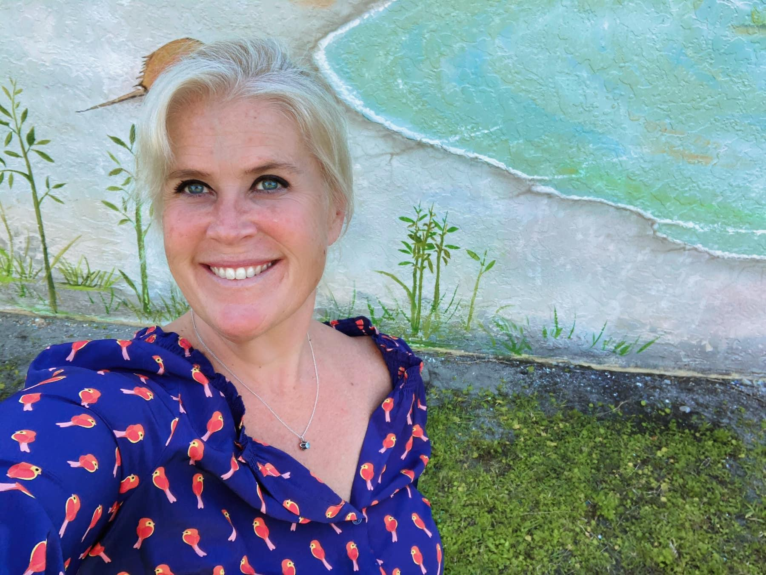
A Native Floridian, conservationist, and urban farmer, Kimberly was born and raised in Orlando. She spent much family time growing up playing on the IRL, heading to the Gulf Stream out of Port Canaveral, and on Brevard beaches. A life-long goal realized, in Spring of 2016 she and her family moved to the beach in Brevard County.
In Summer of 2016 the IRL Fish Kill propelled Kimberly into advocacy and community education about the deteriorating health, causes, and hopeful restoration of the Indian River Lagoon.
Kimberly, a Community Education and Engagement professional, and Certified Aging in Place Specialist through NAHB & AARP, has served as a Community Information officer with the Orange County Commission on Aging and Florida Department of Elder Affairs since 2014.
Kimberly is an Art Instructor and works in Program Development at Orlando Museum of Art with the Dementia Therapy, Autism Arts Integration, and the Youth Education Programs.
Kimberly has served in many community roles since becoming a Brevard resident including, serving as Chair of the U.S. Green Building Council Brevard Local Market, former Chair of the Satellite Beach Beautification Board,
member Brevard County Commission appointed WISER Board,
is an active member of the Brevard Sustainability Working Group,
is Co-Founder of Eco Earth Friends,
Creator of Brevard Environmental Roundtable,
and has been on two Muck Finding Excursions gathering coordinates and physical data on the muck depth and conditions in the IRL and tributaries.
Kimberly finds her most important advocacy role is in educating elected and appointed officials, industry professionals, and homeowners about eliminating chemical fertilizer and herbicide use completely. She represents Brevard County with the University of Florida IFAS & Florida Counties collaborative for marketing and community education on Fertilizer restrictions and alternatives.
Kimberly holds a certification in Florida GI-BMP, Green Industry- Best Management Practices, 2013; and a ‘Flood Management Response’ Certification & ‘Just and Equitable Sea Level Rise Management’ Certification for best present, future, and Disaster Preparedness land use planning along Florida coastlines, 2021.

