# Citizen Oversight Committee Bio: Charlie Venuto, Science/Alternate

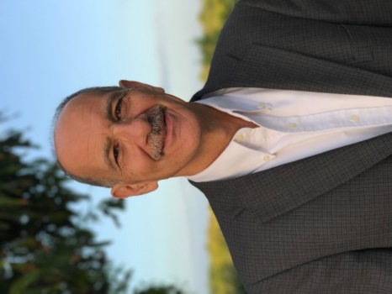

Charlie is the Director of Environmental, Health and Safety at the Kennedy Space Center Visitor Complex. Prior work experience includes over 30 years as an environmental professional supporting the space shuttle program. Charlie is a part time professor in the Environmental Science Department at the American Public University. Charlie is on the Board of Directors of the Merritt Island Wildlife Association. He earned a MS in Environmental Science from Florida Institute of Technology, a MS in Environmental Management and Policy from Rensselaer Polytechnic Institute and a BA in Biology from the State University College at Buffalo.